Write a hive UDF that implements functionality of string concat_ws(string SEP, array). This UDF will accept two arguments, one string and one array of string. It will return a single string where all the elements of the array are separated by the SEP.

UDF:

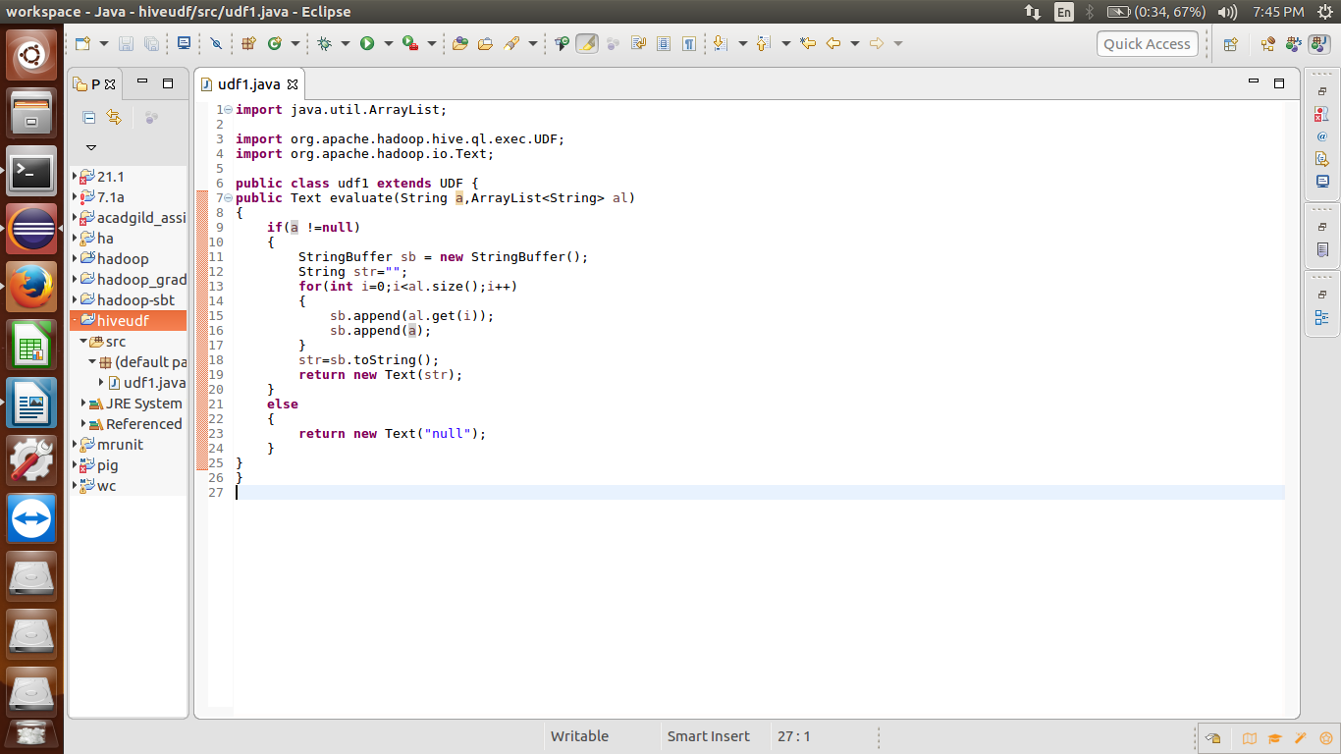

Adding the jar file:



Creating a temporary function and a table:

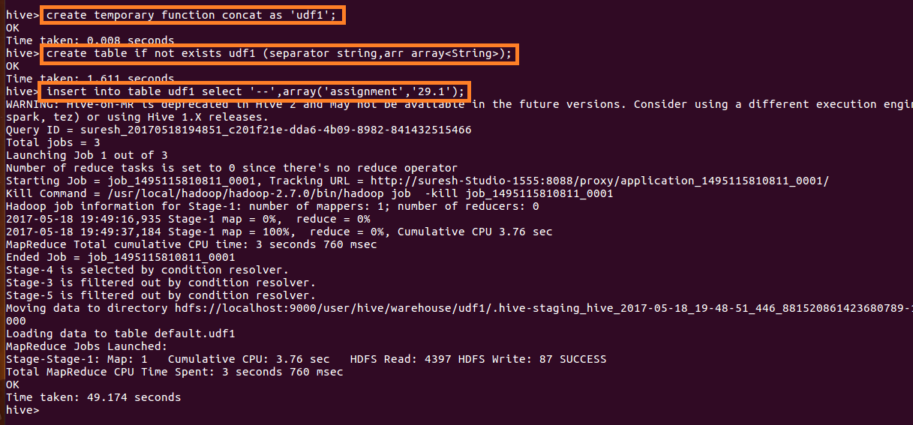

Ouput:

